**Commands for the Scenario Configuration**

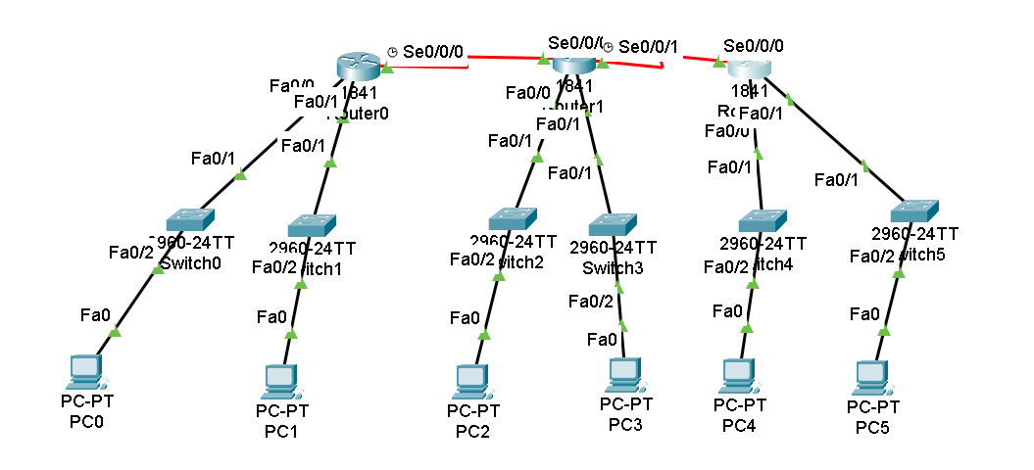

Router>en

Router#conf t

Enter configuration commands, one per line. End with CNTL/Z.

Router(config)#hostname r1

r1(config)#int fa0/0

r1(config-if)#ip add 1.0.0.1 255.255.255.192

r1(config-if)#no shut

r1(config-if)#

%LINK-5-CHANGED: Interface FastEthernet0/1, changed state to up

%LINEPROTO-5-UPDOWN: Line protocol on Interface FastEthernet0/1, changed state to up

r1(config-if)#int fa0/1

r1(config-if)#ip add 1.0.0.65 255.255.255.192

r1(config-if)#no shut

r1(config-if)#int se0/0/0

r1(config-if)#ip add 11.0.0.1 255.0.0.0

r1(config-if)#clock rate 64000

r1(config-if)#no shut

Configuration of the router 2

Router>en

Router#conf t

Enter configuration commands, one per line. End with CNTL/Z.

Router(config)#hostname r2

r2(config)#int fa0/0

r2(config-if)#ip add 2.0.0.1 255.255.255.224

r2(config-if)#no shut

r2(config-if)#

%LINK-5-CHANGED: Interface FastEthernet0/0, changed state to up

%LINEPROTO-5-UPDOWN: Line protocol on Interface FastEthernet0/0, changed state to up

r2(config-if)#int fa0/1

r2(config-if)#ip add 2.0.0.33 255.255.255.224

r2(config-if)#no shut

r2(config-if)#

%LINK-5-CHANGED: Interface FastEthernet0/1, changed state to up

%LINEPROTO-5-UPDOWN: Line protocol on Interface FastEthernet0/1, changed state to up

r2(config-if)#int se0/0/0

r2(config-if)#ip add 11.0.0.2 255.0.0.0

r2(config-if)#no shut

r2(config-if)#

%LINK-5-CHANGED: Interface Serial0/0/0, changed state to up

r2(config-if)#int se0/0/1

r2(config-if)#ip add 12.0.0.1 255.0.0.0

r2(config-if)#clock rate 64000

r2(config-if)#no shut

%LINK-5-CHANGED: Interface Serial0/0/1, changed state to down

r2(config-if)#

r2(config-if)#exit

r2(config)#exit

r2#

%SYS-5-CONFIG_I: Configured from console by console

r2#wr

Building configuration...

[OK]

Router 3 Configuration  
  
Router>en

Router#conf t

Enter configuration commands, one per line. End with CNTL/Z.

Router(config)#hostname r3

r3(config)#int fa0/0

r3(config-if)#ip add 3.0.0.1 255.255.255.240

r3(config-if)#no shut

r3(config-if)#

%LINK-5-CHANGED: Interface FastEthernet0/0, changed state to up

%LINEPROTO-5-UPDOWN: Line protocol on Interface FastEthernet0/0, changed state to up

r3(config-if)#int fa0/1

r3(config-if)#ip add 3.0.0.17 255.255.255.240

r3(config-if)#no shut

r3(config-if)#

%LINK-5-CHANGED: Interface FastEthernet0/1, changed state to up

%LINEPROTO-5-UPDOWN: Line protocol on Interface FastEthernet0/1, changed state to up

r3(config-if)#int se0/0/0

r3(config-if)#ip add 12.0.0.2 255.0.0.0

r3(config-if)#no shut

r3(config-if)#

%LINK-5-CHANGED: Interface Serial0/0/0, changed state to up

%LINEPROTO-5-UPDOWN: Line protocol on Interface Serial0/0/0, changed state to up

Configuration of the Rip commands

Router 1

r1(config)#router rip

r1(config-router)#version 2

r1(config-router)#net 1.0.0.64

r1(config-router)#net 11.0.0.0

r1(config-router)#

r1#exit

Router 2

r2(config)#router rip

r2(config-router)#version 2

r2(config-router)#net 2.0.0.0

r2(config-router)#net 2.0.0.32

r2(config-router)#net 11.0.0.0

r2(config-router)#net 12.0.0.0

r2(config-router)#exit

Router 3  
  
r3(config)#router rip

r3(config-router)#version 2

r3(config-router)#net 3.0.0.0

r3(config-router)#net 3.0.0.16

r3(config-router)#net 12.0.0.0

r3(config-router)#exit

r3(config)#